Comparing Data Among and Across Price Ranges
In the last section, we looked at more in-depth data processing, primarily looking at the higher range of the Kutz 100 violin by looking at its E harmonic spectrum. We determined that even the cheapest instruments have a relatively active super-sonic range, and that it is present and detectable relative to other frequencies in the spectrum.
In this section, we will begin to compare data between same and different price ranges. The Kutz instruments will be compared against each other to determine any trends that may appear in cheaper instruments, and the Cheng and Kono will be compared against each other to determine any trends that may be present in more expensive instruments. At the end, we’ll compare one of the Kutz instruments against the Kono, which are both at extreme ends of our price ranges.
For this section, we’ll be looking at harmonic intensity plots that are overlaid on top of each other. The first plot we’ll look at is the Kutz 100 #1 Open G recording vs. the Kutz 100 #2 Open G recording. The lower third of the harmonic intensity plot for these two recordings can be seen below.

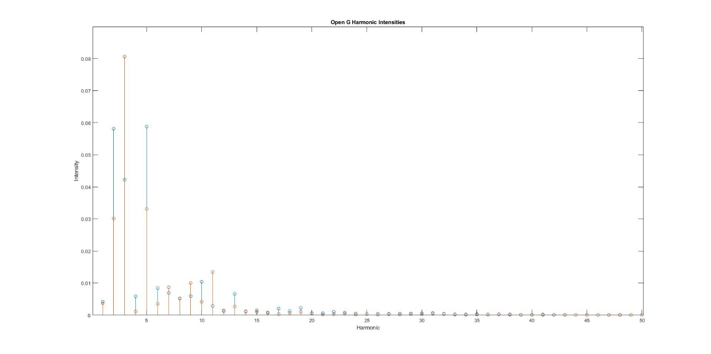
Figure 1: Kutz 100 Open G Spectrum
The orange stems represent the second Kutz 100 recording, and blue stems represent the first Kutz 100 recording. Upon initial inspection, the peak harmonic is different between the two recordings—the peak harmonic for the first Kutz is tied between the 2nd and 5th harmonics, while the second Kutz clearly has its peak at the 3rd harmonic. The intensity of the peaks is also off by about 25%--the second Kutz’s peak is 25% stronger than the first. Other than that, the data seems to be consistent between the two instruments. As we look at higher harmonics, the patterns tend to converge, as expected. Since these two models are the same, we would hope that there isn’t a lot of difference. Since we’re looking at the G string, there is no point in looking at the super-sonic range, since the intensities in this range are not relatively large.
Next, we’ll look at the Open E string recordings for both instruments. The lower third of the harmonics can be seen in Figure 2.

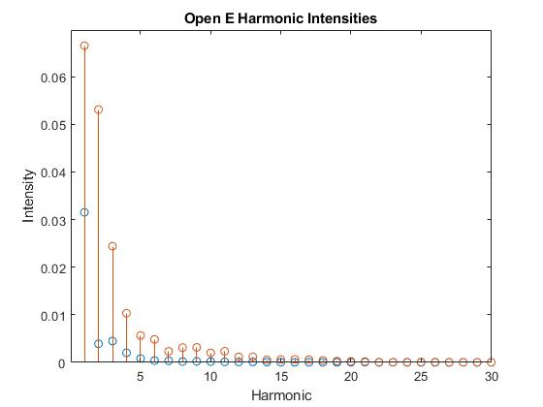
Figure 2: Kutz 100 Open E Spectrum
For the open E, the two instruments follow a much more similar trend—the peaks in both instruments occur at the first harmonics, followed by a similar exponential decay until the trends converge. Note that the second instruments intensities are always greater than the first instrument. This may be due to the fact that the second instrument’s recording is both shorter and louder, leading to a more concentrated spectrum. The fundamental for this instrument is 659 Hz, meaning that the 30th harmonic would put us near the super-sonic range. It is evident that the 30th harmonic in this case is not relatively large, so the upper frequencies can also be neglected here.
Next, we’ll look at the Open G Harmonic recordings for both of the instruments. We expect the peak for all of these to be two octaves (or two harmonics) higher than the fundamental, as the open-string harmonic on violins produces a pitch that is two octaves higher than the fundamental pitch on the string. These plots can be seen in Figure 3.

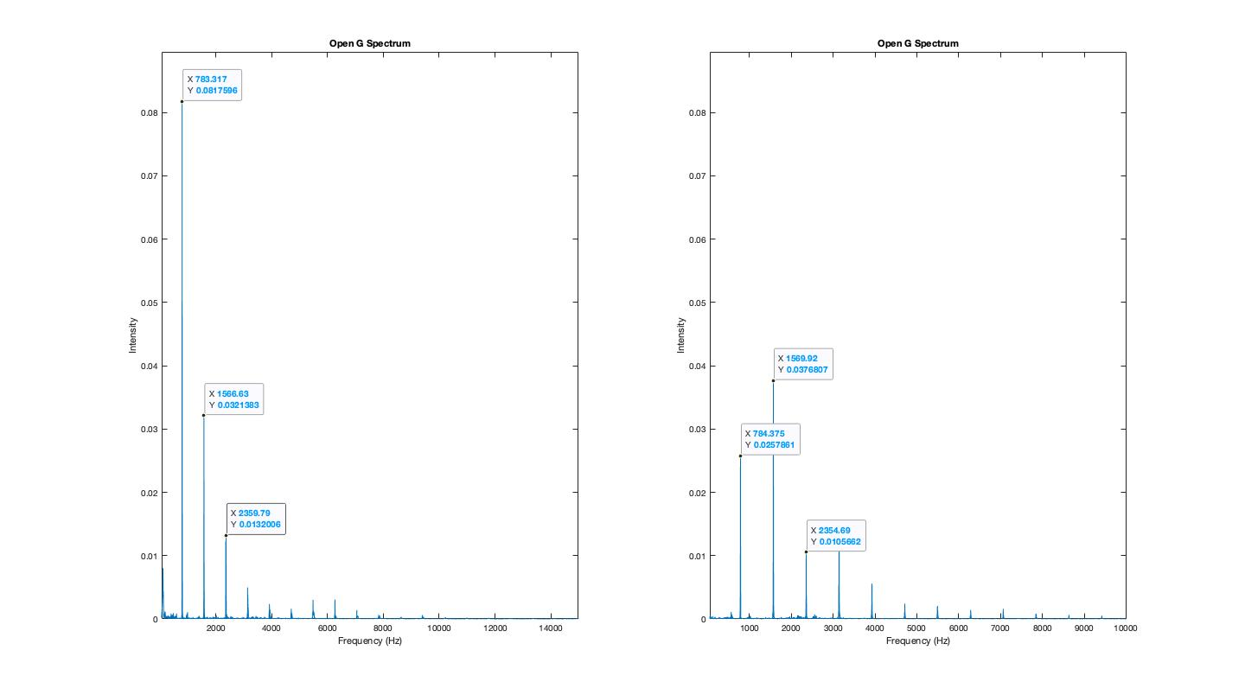
Figure 3: Open G Harmonic Spectra
Looking at the harmonic spectra gives us some more consistency among the data—note that while the first harmonic intensities are very different, the second and third harmonics have almost the exact same intensity between the two instruments. This makes sense and is in line with what we would expect—the first harmonic’s wide discrepancy can be attributed to volume and duration of the recording. The upper frequency range for this instrument also follows the same general trend. Since we’re looking at the G string, the upper spectra can be neglected, as peaks are not relatively strong here.
Next, we’ll look at the Open E Harmonic for both recordings. For this sample, we need to look at the lower and upper frequency range, as we know from the last section that this contains relatively strong super-sonic frequencies. These plots can be seen in Figures 4 and 5.

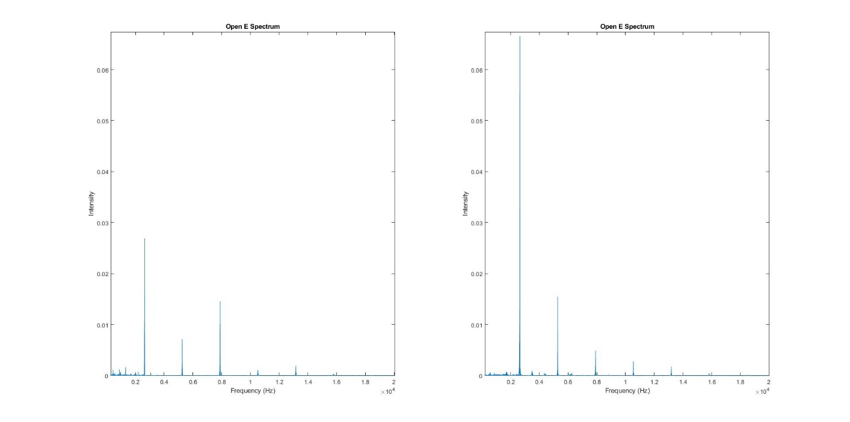
Figure 4: Open E Harmonic Lower Spectrum
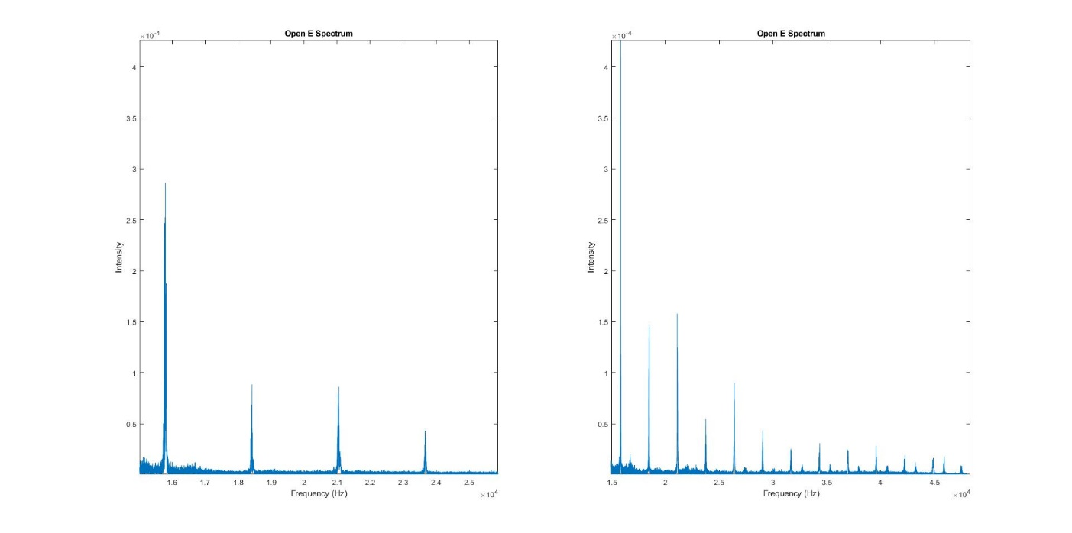
Figure 5: Open E Harmonic Upper Spectrum

For this recording, we see that the second instrument has a more active spectrum throughout the upper and lower ranges. This may be because of inconsistencies or errors in recording, as the spectra of the two instruments has been relatively consistent thus far. There is little to no consistency across the two instruments in this case, which may be cause for concern—this much error in the recording process is unlikely, so it’s possible that the two instruments may not be exact replicas.
Regardless, we find that the upper spectrum is more active than any of the other strings, as we expected. The first instrument has relative peaks in the super-sonic range that last until about 24 kHz, while the second instrument has a much more active super-sonic range. The second instrument has a super-sonic range that is relatively significant into around 40 kHz. It should be noted that while there are peaks in this area, they aren’t necessarily harmonics. We can determine this from the fact that we would expect the peaks to be evenly spaced, as harmonics occur on even intervals. The spacing is more inconsistent in frequencies above 30 kHz.

